Cyber Attack Behavior & Structural Defenses

Overview
This document simplifies complex cybersecurity concepts into an easy-to-understand guide. It covers how we track threats, the "playbook" used to categorize hacker behavior, a real-world case study on gaming account theft, and the best ways to defend against these attacks.

1. Cyber Threat Intelligence (CTI)
CTI is not just a list of bad IP addresses. It is knowledge used to understand who is attacking, how they do it, and what they want.

- Strategic: High-level trends for CEOs (Who is attacking our industry?).
- Tactical: The methods and tools used by hackers (How are they getting in?).
- Operational: Real-time data like file signatures for security analysts (What is happening right now?).

2. The MITRE ATT&CK Framework
Think of this as the Periodic Table of Cyber Attacks. It categorizes every action a hacker might take.

- Tactics: The attacker's goal (e.g., "Initial Access" or "Stealing Data").
- Techniques: The specific way they achieve that goal (e.g., "Phishing").
- Procedures: The exact commands or software used in a real attack.

3. Case Study: The "TenZ" Val Skin Scam


This real-world example shows how attackers stole high-value VALORANT gaming accounts by pretending to be a famous professional player.

How the Attack Worked
- The Hook: Attackers ran a fake "Skin Giveaway" live stream using stolen footage of a pro player.
- The Trap: A link in the chat sent users to a fake login page that looked exactly like the official game site.
- The Theft: When the user typed their login and MFA (2-factor) code, a "Proxy" server captured them in real-time. This allowed the attacker to bypass security and instantly change the account's recovery email.
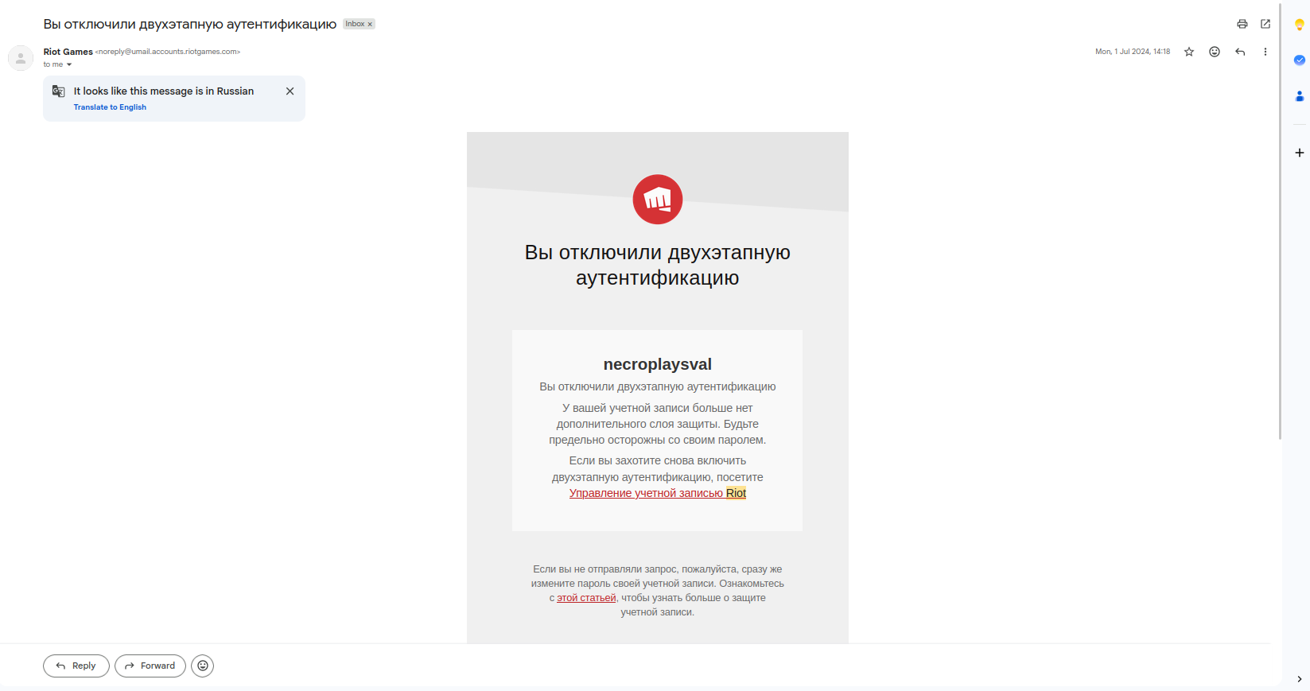

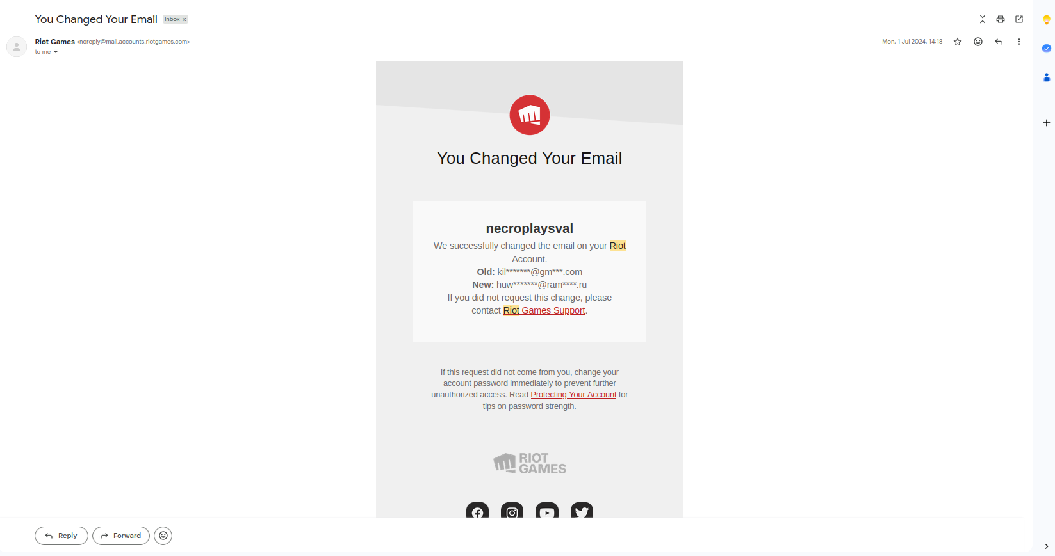

4. Why 2-Factor Authentication (MFA) Sometimes Fails
Modern hackers use Adversary-in-the-Middle (AiTM) attacks. They act as a "middleman" between you and the real website. When you enter your 2-step code, they catch it and use it before it expires.

Security Control | Why It Matters | Simple Explanation
FIDO2 / Passkeys | Best Protection | Uses a physical key or fingerprint that only works on the real website.
DMARC/SPF | Email Security | Stops hackers from sending emails that look like they came from a real company.
Token Binding | Cookie Security | Locks your "login session" to your specific device so a hacker can't steal it.

5. How to Protect Yourself
To stay safe, follow these three simple rules:

- Check the URL: If the website address is even one letter off (e.g., real-game.cc instead of realgame.com), it is a scam.
eg:https:tenzval.com
- Trust No One: Real companies will never ask you to log in to a third-party site to claim a "free prize."
- Use Hardware Keys: Whenever possible, use physical security keys or "Passkeys" instead of text-message (SMS) codes.


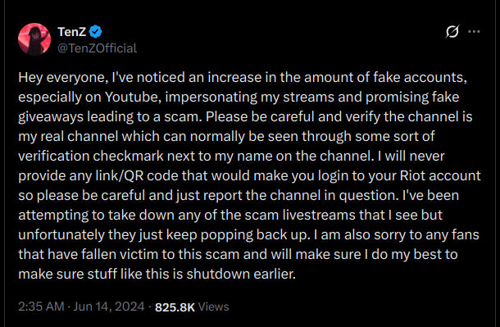
- 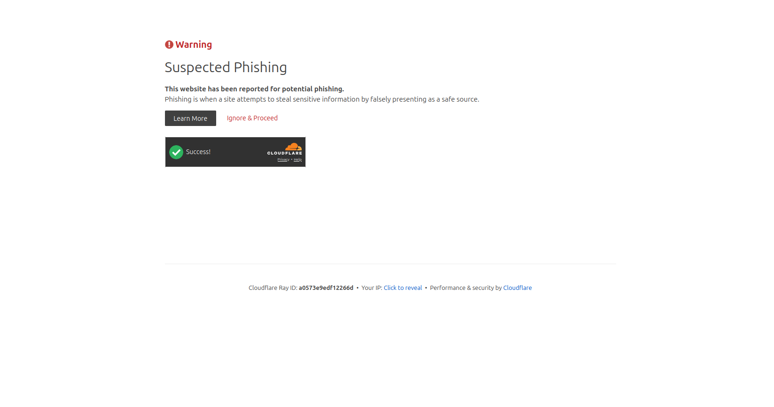


CHAPTER 11: Attack Timeline: The Five Stages of Theft
This attack follows a clear plan, from setting up the trap to stealing the cash.

Stage 1: Preparation
- Set up the Fake Site: Hackers buy fake domain names (like riotgames-claims.cc) and get the padlock icon (SSL) to look trustworthy.
- Build the Proxy: They set up a special server (Reverse Proxy) that will secretly stand between you and the real game server.

Stage 2: Lure and Distribution
- Use Famous Faces: They hijack popular streaming accounts and use video loops of pro players (like TenZ) to promote a fake "Skin Giveaway."
- Fake Testimonials: Bots flood the chat with fake comments like, "Just got my skin, it works!" to pressure you into clicking the link.

Stage 3: AiTM Interception (The Theft)
- Real-Time Capture: When you type your login and 2-factor code into the fake site, the hacker's proxy instantly sends it to the real server.
- Steal the Session Key: The proxy catches the authenticated Session Cookie (the key that keeps you logged in) from the real server and saves it, completely bypassing your MFA protection.

Stage 4: Lockout and Deception
- Instant Takeover: An automated script uses the stolen session key to immediately change your recovery email and phone number.
- The 30-Day Lie: The fake site tells you the rewards will take 30 days to process and warns you not to check your account settings. This is a trick to make you ignore real security warnings.

Stage 5: Asset Liquidation
- Inventory Sale: Once the account is secured, automated tools list the high-value skins, badges, and the entire profile on underground markets for anonymous cryptocurrency.

CHAPTER 12: Expert Insights: Why This Attack Works
The campaign succeeds by exploiting human behavior and system vulnerabilities.
- Weaponizing Trust: Attackers use the image of a trusted athlete (TenZ) in a familiar space (streaming platform) to make users drop their guard, overriding their normal security checks.
- Exploiting the Safety Window: The core trick is abusing the platform's 7-Day Security Grace Period. The hacker's 30-day delay message keeps the victim quiet until the 7-day period expires, and the system automatically approves the hacker's permanent control.
- MFA is Failing: Traditional 2-factor authentication (SMS/App codes) is useless against AiTM proxies because the hacker intercepts the code in real-time. Security must shift to hardware-bound solutions like FIDO2 Passkeys.

CHAPTER 13: Technical Blueprints (Simplified)

13.1 AiTM Attack Flow
- The hacker's server acts as a silent middleman between the victim and the real game server.
- It steals the one thing that matters: the Session Cookie, which proves you are logged in.

13.2 Hacker Database
- Hackers organize their stolen data to include the username, the stolen Session Cookie, and a note often stating exfiltration_state: 'PENDING_GRACE', confirming they are waiting for the 7-day lockout period to end.

CHAPTER 14: Digital Defensive Awareness
Use these two key messages to protect users:

Poster 1: Check the URL
- The Rule: Attackers can copy everything (logos, buttons) but they cannot copy the official domain name.
- Danger Signs: Look for strange extensions (.cc, .net), or hyphens in the wrong place. If the URL is wrong, close the tab immediately.

Poster 2: Ignore the Delay Lie
- The Lie: Any site claiming rewards will take a "week or a month to process" is a scam.
- The Truth: They stole your login and are waiting for the 7-Day Grace Period to end.
- Action: If you see this message, immediately check your backup email for a cancellation link to stop the unauthorized change.

CHAPTER 15: Real-World Case Studies
This tactic is not new; it has been used in major corporate breaches:
- Twilio Identity Harvesting (2022): Hackers used AiTM reverse proxies via SMS (smishing) to steal employee MFA codes and Session Cookies, gaining access to the company's network.
- Rockstar Games Intrusion (2022): The hacker didn't use advanced exploits. They bought a stolen login and used an MFA Fatigue Attack (flooding the victim's phone with hundreds of approval notifications late at night) until the tired employee hit "Approve" and granted access.


